VIDYA JYOTHI INSTITUTE OF TECHNOLOGY
ACADEMIC NEWSLETTER – FEBRUARY 2026 EDITION

Editorial Note
Dear Ruhi Khan,
It gives us immense pleasure to present the September edition of our Academic Newsletter. This month has been filled with exciting academic activities and student achievements that reflect our college’s commitment to excellence.

Academic Events & Workshops
- Workshop on Data Science (5th February): Organized by the Department of Computer Science with hands-on sessions on Python and Machine Learning.
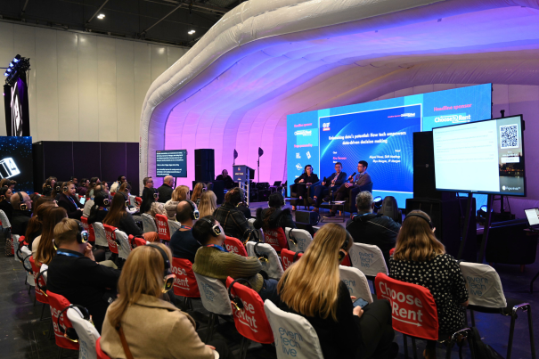
Fig. 1. Workshop on Data Science

Guest Lectures & Seminars
- “AI in Healthcare” by Dr. Meera Sharma (AIIMS, Delhi) – Highlighted the role of artificial intelligence in medical diagnosis.

Student Achievements
- Rahul Verma (B. Tech IT) won 1st Prize in the Inter-College Coding Hackathon.
- Priya Singh (MBA) presented her research paper at the National Business Conference in Bangalore.

Announcements
- Mid-Semester Exams: Commence from 15th February.
- TEDxVJIT event is scheduled on February 21, 2026. Various industry experts are invited to participate.
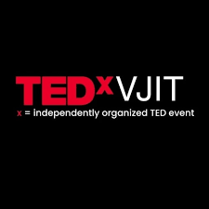
Fig. 2. TED^{x}VJIT

